1. ***Write a JAVA code to print sum of 2 numbers. Get input from user.***

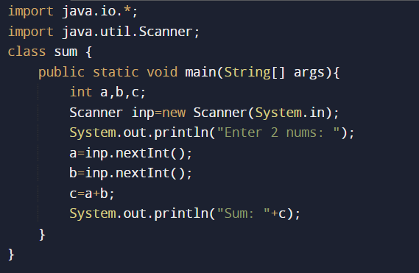

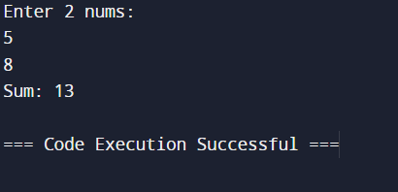

1. ***Write a JAVA code to calculate the area and circumference of circle. Get input from user.***

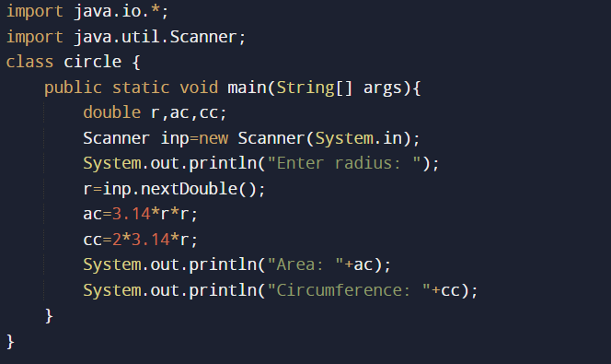

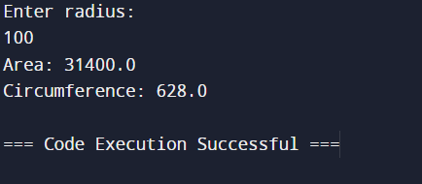

1. ***Write a JAVA code for arithmetic operations. Get input from user.***

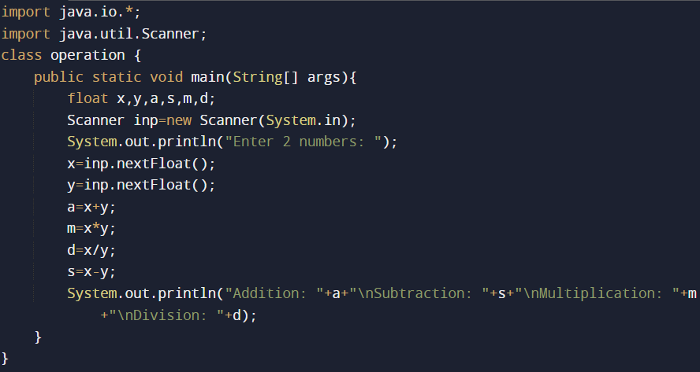

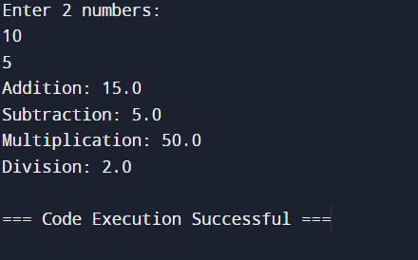

1. ***Write a JAVA code to get sum and average of 5 numbers. Get input from user.***

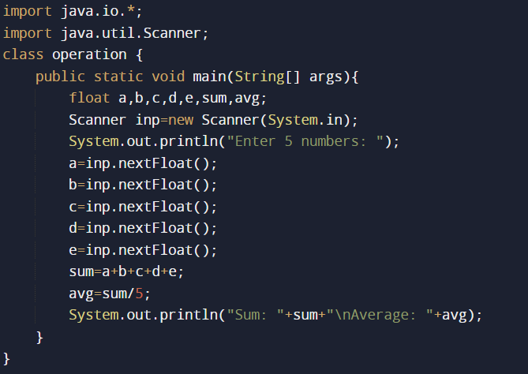

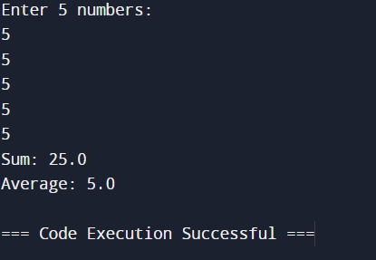

1. ***Write a JAVA code to calculate Simple interest and compound interest. Get input from user.***

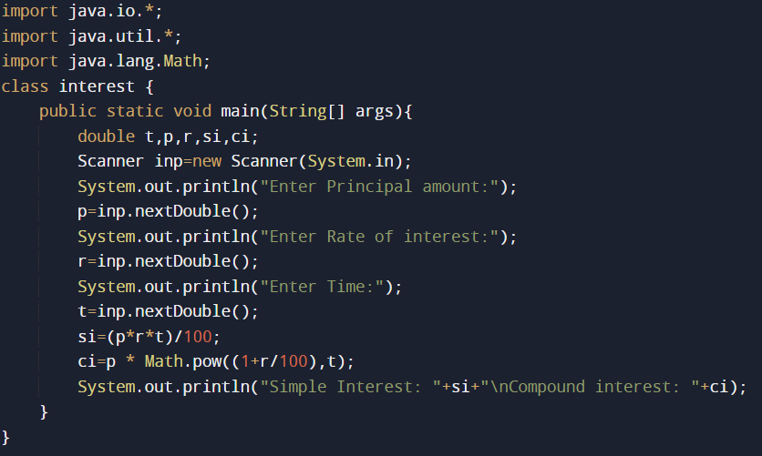

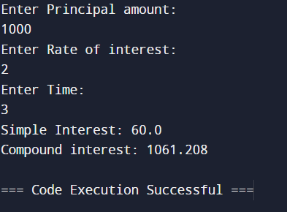

1. ***Write a JAVA code print your home address. Get input from user.***

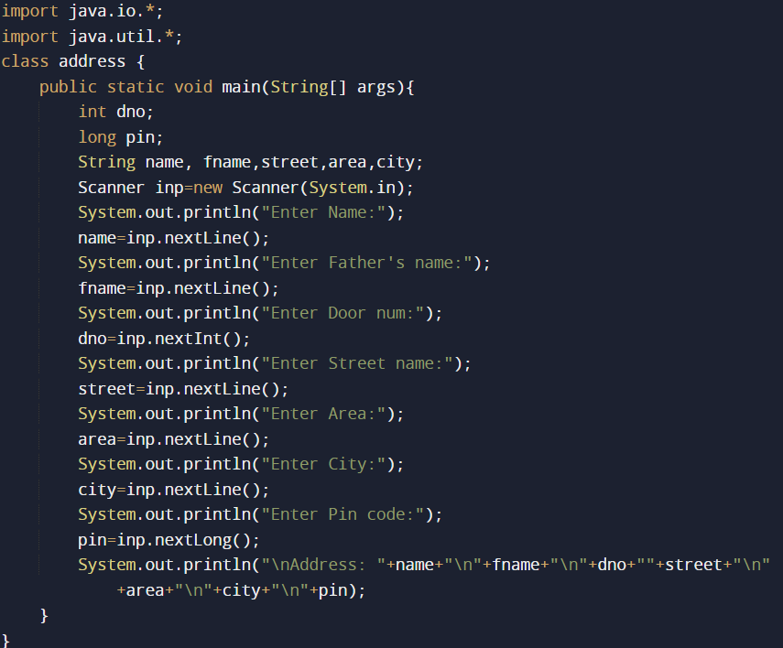

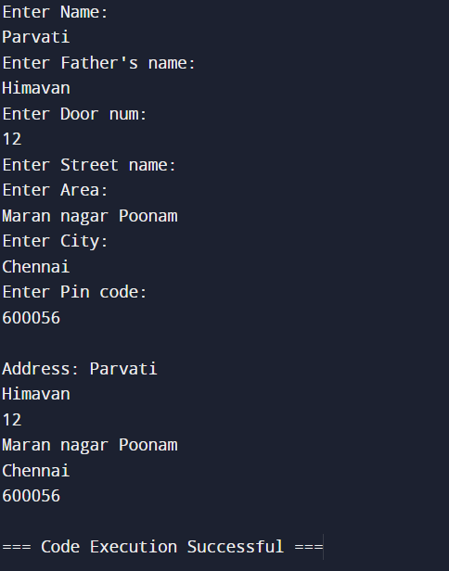

1. ***Write a JAVA code to prepare your student report and calculate the total average for the student. Input fields are Reg num.,Name, m1,m2,m3,m4,m5. Get input from user.***

